Lost and Found System

BY

7-2-410-222-2020

Prime College

A Summer Project Submitted to

Faculty of Management, Tribhuwan University

in partial fulfillment of the requirements for the degree of

Bachelor of Information Management

Place

Month/ year

# Student’s Declaration

This is to certify that I have completed the Project entitled “Lost and Found System” under the guidance of “Er. Shravan Ghimire” in partial fulfillment of the requirements for the degree of Bachelor of Information Management at the Faculty of Management, Tribhuwan University. This is my original work and we have not submitted it earlier elsewhere.

Date:

Signature

Name:

# Certificate from the supervisor

This is to certify that the summer project entitled “Lost and Found System” is an academic work done by “” submitted in the partial fulfillment of the requirements for the degree of Bachelor of Information Management at Faculty of Management, Tribhuwan University under my guidance and supervision. To the best of my knowledge, the information presented by her in the summer project report has not been submitted earlier.

Signature of the Supervisor

Name: Er. Sravan Ghimire

Designation:

Date:

# Acknowledgment

I am immensely grateful to all the individuals who have contributed to the successful completion of this project. Without their support and guidance, this project would not have been possible.

First and foremost, I would like to extend my heartfelt thanks to my supervisor, Er. Sravan Ghimire, for his valuable guidance, support, and feedback throughout the development process. His expertise and insight were crucial in shaping the successful execution of this project.

I would also like to acknowledge the faculty members of Prime College, Khusibun, for fostering an environment of learning and innovation. Their unwavering commitment to academic excellence has been a source of inspiration throughout my journey.

Furthermore, I am grateful to my family and friends who have been patient and understanding during the demanding phase of this project.

This project has been an enriching experience, and I am truly thankful to everyone who played a role, no matter how small, in making it a reality. Executive Summary

Table of Contents

Student’s Declaration ii

Certificate from the supervisor iii

Acknowledgment iv

List of Figures viii

List of Tables ix

Abbreviations x

1 Chapter 1: Introduction 1

1.1 Background 1

1.2 Introduction of the organization 1

1.3 Current situation of the organization 1

1.4 Issues/ Problems in the organization 1

1.5 Objectives of the report 1

1.6 Scope and limitation 1

1.7 Methodology of the Study 1

1.7.1 Analysis of the problem 1

1.7.2 Data Collection and Analysis 1

1.7.3 Tools used 1

2 Chapter 2: analysis of activities done and problem solved 4

2.1 Analysis of Current Situation 4

2.2 Requirement Analysis 4

2.2.1 Requirement Collection methods 4

2.2.2 Functional Requirements of the system 4

2.2.3 Non-functional requirements of the system 4

2.3 System design 4

2.3.1 System architecture 4

2.3.2 UML Class Diagram 4

2.3.3 Sequence Diagram 4

2.3.4 Activity Diagram 4

2.3.5 Database Schema 4

2.3.6 Component Diagram 4

2.3.7 Deployment Diagram 4

2.4 System Implementation 4

2.4.1 System development Methodology Used 4

2.4.2 Modules Description 4

2.5 System Testing 4

2.5.1 Unit testing with test cases 4

2.5.2 Integration testing with test cases 4

3 Chapter 3: discussion and conclusion 5

3.1 Discussion 5

3.2 Conclusion 5

3.3 Lessons Learnt 5

3.4 Recommendation 5

Reference 5

Appendix 5

# List of Figures

Figure repo app

<https://www.repoapp.com/wp-content/uploads/2020/01/Power-search-1024x586.png>

Figure 2.1: RepoApp’s Power Search 5

# List of Tables

# Abbreviations

HMTL: Hypertext Markup Language

CSS: Cascading Style Sheet

PHP: Hypertext Preprocessor

MySQL: My Structured Query Language

# Chapter 1: Introduction

## Background

## Introduction of the organization

Prime College is an esteemed educational institution that endeavors to provide practical-based education and empower young minds. Its aim is to foster a culture of excellence among skilled individuals. It offers a diverse range of academic programs at both undergraduate and graduate levels. The faculty comprises dedicated and experienced members who bring their expertise to the classroom, creating a dynamic learning environment.

## Current situation of the organization

The college has implemented a robust system for managing lost items. This system involves the reception acting as a central point for reporting and returning lost items that are found by students or staff members. The reception desk is open to inquiries from students regarding lost items, and they make it a priority to return all found items to their rightful owners. In addition to this, the reception has also taken the proactive step of posting pictures of lost items on the college's Viber virtual notice board, which greatly assists students in identifying their belongings. This approach reflects the college's commitment to providing a safe and secure environment for all students, faculty, and staff.

There is no system in place for students to look up or report lost belongings. They must repeatedly check with reception to see if anything has been turned in..

## Issues/ Problems in the Organization

## Objectives of the report

1. To provide a centralized way of managing lost and found items.
2. To send notifications to the users about the found items.

## Scope and limitation

**Scope**

1. **Efficient Retrieval**: The system facilitates quicker retrieval of lost items compared to manual methods, enhancing convenience for users.
2. **User Reporting**: Users can report missing items and provide essential details like description and possible location, streamlining the process of logging lost items.
3. **Automated Notifications**: Automated notifications alert users when similar lost items are found, improving the chances of items being reclaimed promptly.
4. **Database Search**: Users can search for lost items in the system database based on their description, simplifying the search process.
5. **Database Maintenance**: The system maintains a database of lost and found items, ensuring efficient tracking and management, which contributes to the overall effectiveness of the process.

**Limitation**

1. **Image-based search**: The system lacks the capability to search for items based on images, which could limit the search options for users.
2. **Limited filtering options**: Users cannot filter data items according to date found or location, potentially hindering the efficiency of searches.
3. **Order of displayed items**: Users cannot change the order of displayed items, which may affect the ease of browsing through the database.
4. **Ownership verification**: Verifying the ownership of lost items can be challenging, posing a potential hurdle in returning items to their rightful owners.
5. **False reports and claims**: There is a possibility of false reports or claims, leading to wasted time and resources in investigating such incidents and potentially causing disruptions in the system's functionality.

## Methodology of the Study

### Analysis of the problem

### Data Collection and Analysis

### Tools used

* Frontend
  + HTML
    - User Interface Design
    - Layout of pages
    - Displaying records
    - Forms and user inputs
    - Hyperlinks and navigation
  + CSS
    - Layout and Design
    - Styling elements
  + Bootstrap
    - Customized alerts and notifications
    - Pre-styled components
  + JavaScript
    - Input Validation
    - User notifications and alerts
* Backend
  + PHP
    - User Authentication and Authorization
    - Database Interaction
    - Content Delivery
    - Notifications and Communication
  + MySQL
* Admin Data Storage
* Update Data Storage

# Chapter 2: analysis of activities done and problem solved

## Analysis of Current Situation

1. RepoApp

RepoApp provides companies and organizations with a centralized platform for managing lost and found items, claims, as well as user roles. Widely adopted across various industries such as hospitality, education, recreational, and facility management, RepoApp offers a suite of services including mobile device management, lost and found item management, claim management, and lost item search functionalities.

Primarily embraced within educational institutions, particularly universities, RepoApp serves as a pivotal tool for several reasons:

* It automates the matching process between lost items and corresponding claim tickets, streamlining the reconciliation process.
* RepoApp significantly enhances return rates by facilitating efficient item identification and retrieval.
* Students benefit from the convenience of locating their lost items using their mobile devices or laptops, reducing the need for frequent inquiries and visits to administrative offices.
* Founders and administrators can promptly report found items without the necessity of physically visiting school management offices repeatedly.
* The platform effectively eliminates the laborious manual search process traditionally associated with locating lost items, thereby saving valuable time previously spent on searching through storage bins, spreadsheets, or paper logs.

In summary, RepoApp serves as an indispensable solution for managing lost and found items and claims, offering enhanced efficiency, convenience, and accuracy, particularly within educational settings.

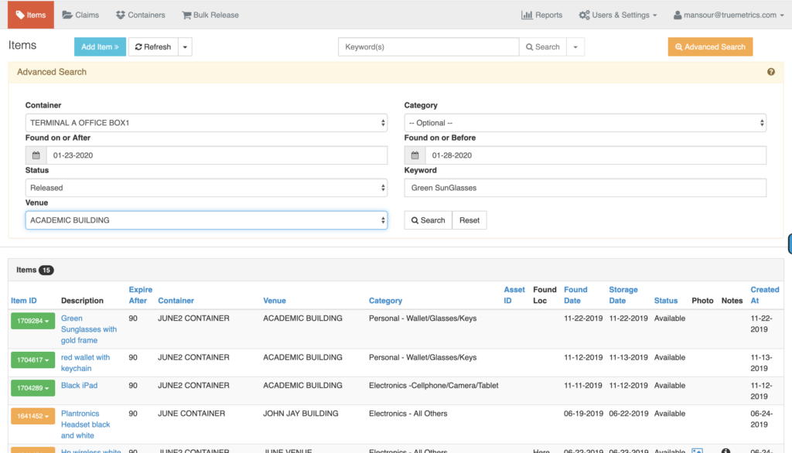

Figure 2.1: RepoApp’s Power Search

1. Lostings

Lostings is an online platform designed to modernize the process of reporting and managing lost and found items. It offers a unique system that caters to both individual users and businesses. For individual users, Lostings provides a user-friendly interface to report, describe, and categorize lost or found items. Users can also add location information, upload photos, and provide detailed descriptions, as well as generate flyers for local awareness. The platform includes a dynamic matching system that sends email notifications and alerts to users when matching or similar items are reported. Additionally, Lostings offers a Lost and Found Inventory Management Software tailored for businesses, enabling them to efficiently manage lost and found items within their organization. Overall, Lostings aims to simplify the process of lost and found item management for both individuals and businesses through its comprehensive and user-centric platform.

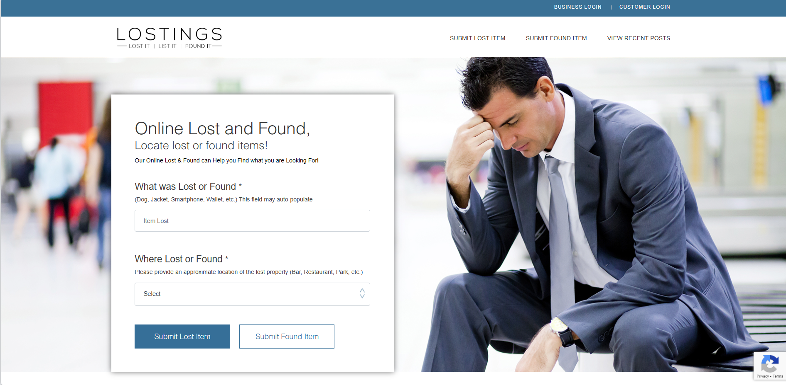

Figure 2.2: Lostings website

## Requirement Analysis

### Requirement Collection methods

### Functional Requirements of the system

1. To be able to register (only students).
2. To be able to log in, both admin and students.
3. Search for items using keywords.
4. Get a notification when similar reported items are newly added.
5. To be able to see all the found items in the database.

### Non-functional requirements of the system

1. Security
2. Performance (response time)
3. Efficiency
4. Usability

## System design

### System architecture

### UML Class Diagram

### Sequence Diagram

### Activity Diagram

### Database Schema

### Component Diagram

### Deployment Diagram

## System Implementation

### System development Methodology Used

### Modules Description

## System Testing

### Unit testing with test cases

### Integration testing with test cases

# Chapter 3: discussion and conclusion

## Discussion

## Conclusion

## Lessons Learnt

## Recommendation

# Reference

1. Chin, Y. T. (2020). UTAR Lost and Found Management System (Bachelor of Science (Honours) Software Engineering). Lee Kong Chian Faculty of Engineering and Science, University Tunku Abdul Rahman. Retrieved from <http://eprints.utar.edu.my/4084/1/1701169_FYP_report_-_YUN_TING_CHIN.pdf>
2. Kaur, H. (2017). Lost and Found Web Application for Cal Poly Pomona Students (Master of Science in Computer Science). California State Polytechnic University, Pomona. Retrieved from <https://scholarworks.calstate.edu/downloads/pk02cc79g>
3. Prime College. (n.d.). Retrieved April 25, 2024, from <https://prime.edu.np/>
4. RepoApp. (n.d.). Retrieved April 25, 2024, from <https://www.repoapp.com/>

# Appendix